Bridgepoint Parts Catalog

Section XXVII: Briggs & Stratton Engine Parts Page 1

PFR-394018

Air Filter

Paper Filter – Round

Most common air filter used on most Briggs & Stratton equipped truck mounts. Prochem, Bridgepoint & Hydramaster

PFR-805113

Air Filter

Paper Filter – Rectangular/Flat

Used on older truck mounts using the early versions of the 16HP Vanguard engine.
Prochem: Cub & CubXL
Bridgepoint: System IV
Hydramaster: Aquacat 3.5 & 3.9
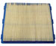
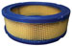

PFR272490

Air Filter – Pre-cleaner

Foam – Round

Used with PFR-394018 Air Filter

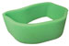

PFR-805267

Air Filter – Pre-cleaner

Foam – Rectangular/Flat

Used with PFR-805113 Air Filter



PBL36385

Air Filter - Primary

Briggs & Stratton 35HP
Hydramaster: Boxxer 421
Sapphire: 454SS

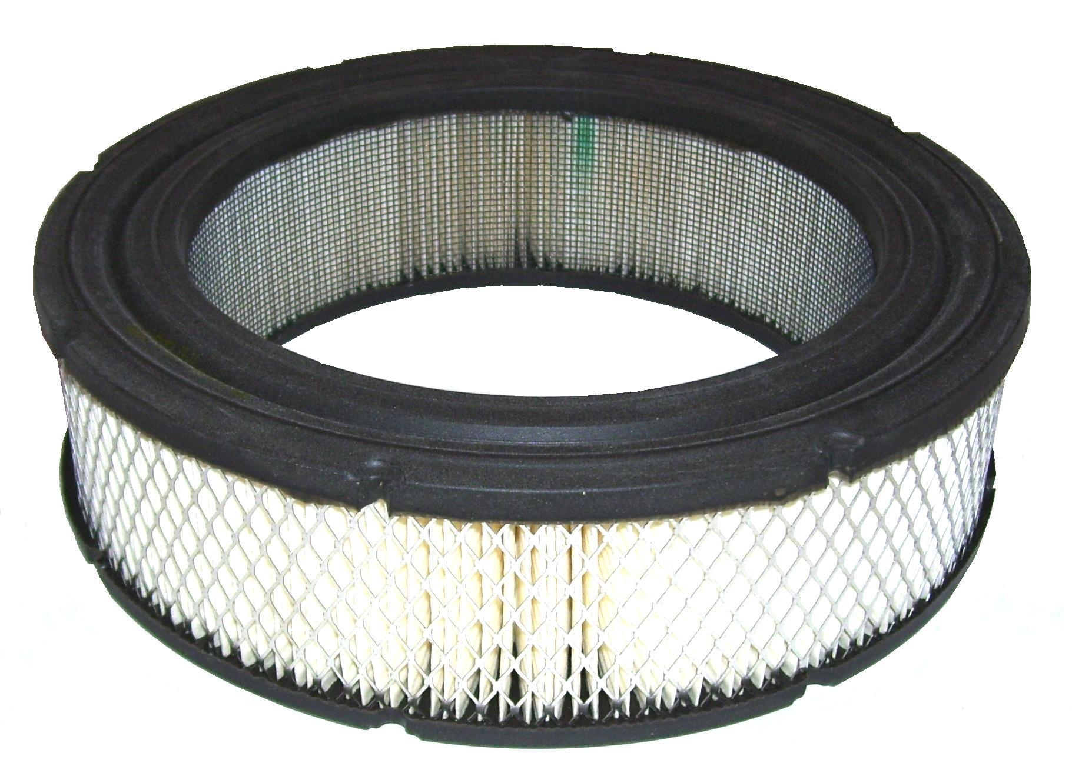

PFR491056

Oil Filter - Larger

Used on old Briggs I/C engines that had oil filters. Prochem: 100A
Hydramaster: Bobcat

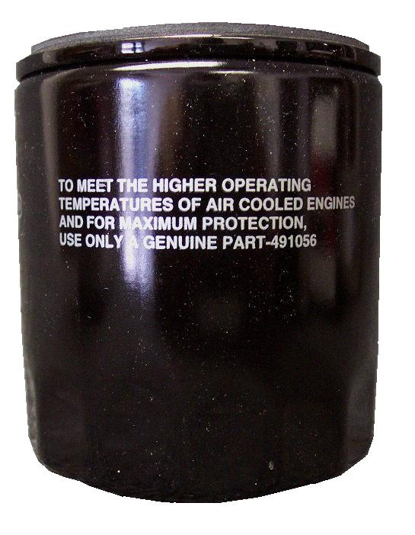

PFR692520

Air Filter – Pre-cleaner

Foam – Round
Used with PFR692519 Air Filter
Hydramaster: Boxxer 421
Sapphire: 454SS

PFR492932

Oil Filter – Smaller

Prochem: Trailblazer, Blazer, Blazer Plus, Blazer GT, Blazer XL, Cub,
Cub XL, Power Vac & Oil Fired TM.
Bridgepoint: System IV, Saber, Saber 2000 & Dagger
Hydramaster: Boxxer 421, Boxxer 427, Crossfire 3.7, Profire 3.7, Spitfire 3.2, Spitfire 4.0, Hydracat 3.5, Maxx 450D, Maxx 470D & Aquacat 3.5 & 3.9 Sapphire: 270SS
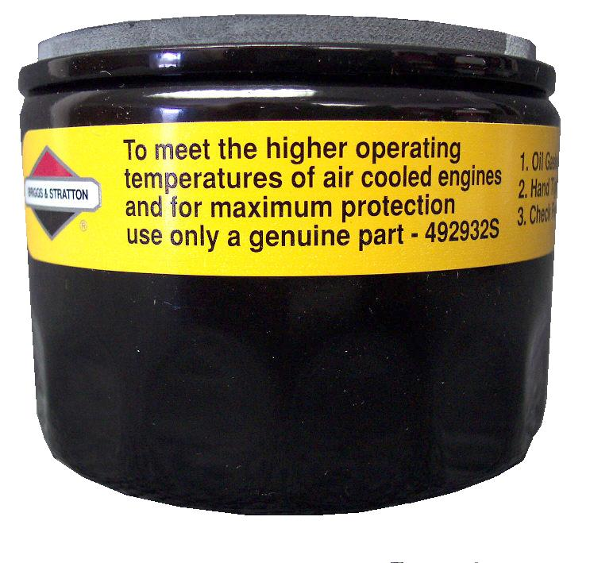

PBL36384

Oil Filter

Briggs & Stratton 35HP
Sapphire: 454SS

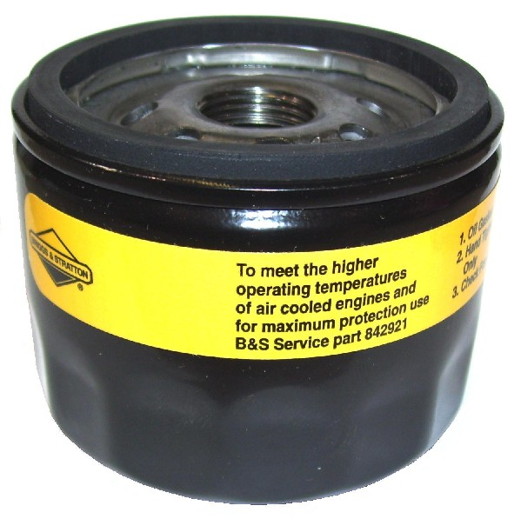

PHY049-063

Air Filter

Paper Filter – Cylinder
Briggs & Stratton Daihatsu
Hydramaster: Boxxer 427,
Maxx 450D & 470D

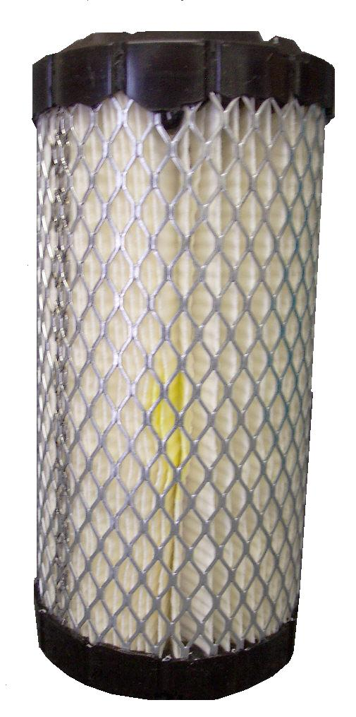

PHY049-134

Filter Diesel Fuel Element

Hydramaster: Maxx 450D Diesel

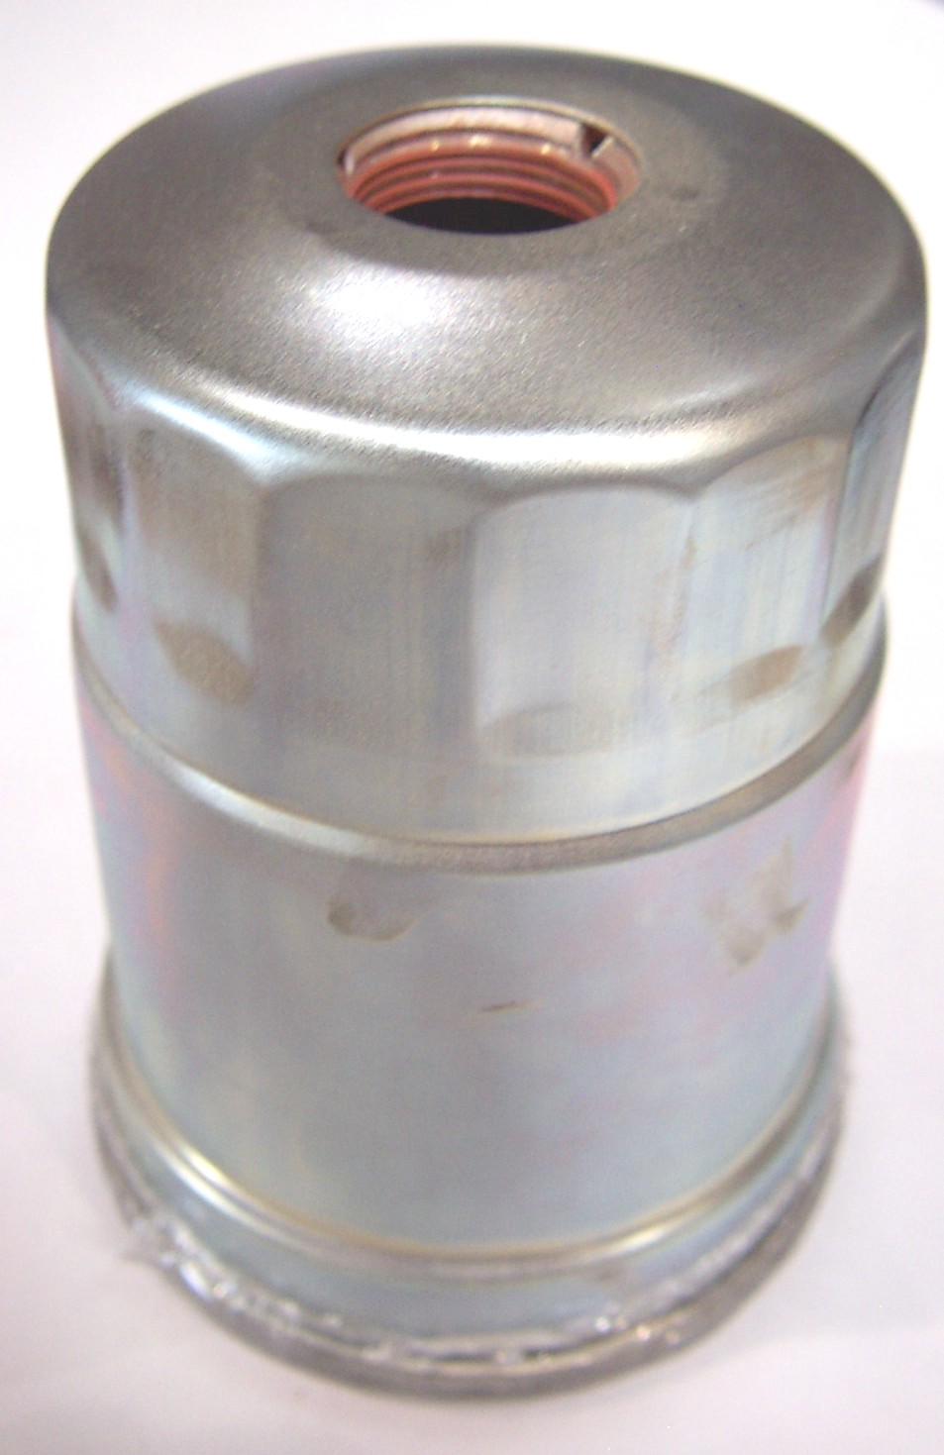

PFR493629

Fuel Filter – Briggs

60 micron

3.54” x 7.05”
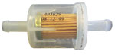

PFR807795

Breather – Briggs & Stratton
Most Vanguard Engines
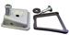

PFR394358

Fuel Filter – Briggs

75 micron
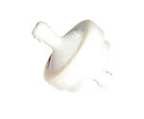

Bridgepoint Parts Catalog

Section XXVII: Briggs & Stratton Engine Parts Page 2

PFR-RC12YC

Spark Plug RC12YC
Briggs & Stratton Vanguard Engines

Prochem: Trailblazer, Blazer, Blazer Plus, Blazer XL,
Blazer GT, Cub, Cub XL, Power Vac & Oil Fired TM.
Bridgepoint: System IV, Saber, Saber 2000 & Dagger
Hydramaster: Boxxer 421, Boxxer 427, Crossfire 3.7,
Profire 3.7, Spitfire 3.2, Spitfire 4.0, Hydracat 3.5, Maxx 450D, Maxx 470D & Aquacat 3.5 & 3.9
Sapphire: 270SS

PFR-RJ12
Spark Plug RJ12
Briggs & Stratton I/C Engines
Prochem: 100A
Hydramaster: Bobcat

PFR394890

Voltage Regulator - 16AMP

Briggs & Stratton

All Vanguard Engines with 10 & 16 amp regulated charging systems

PHY157-028

Switch – Oil Pressure

PFR841170

Voltage Regulator- 50AMP

Briggs & Stratton
Hydramaster: Boxxer 421 &
Boxxer 427

PFR691656

Solenoid – Starter

Briggs & Stratton
Bridgepoint: Dagger
Hydramaster: Boxxer 421, Spitfire 3.2 & Spitfire 4.0

PHY157-037
Solenoid – Charging Switch
50amp Charging Systems
Hydramaster: Boxxer 421 &
Boxxer 427

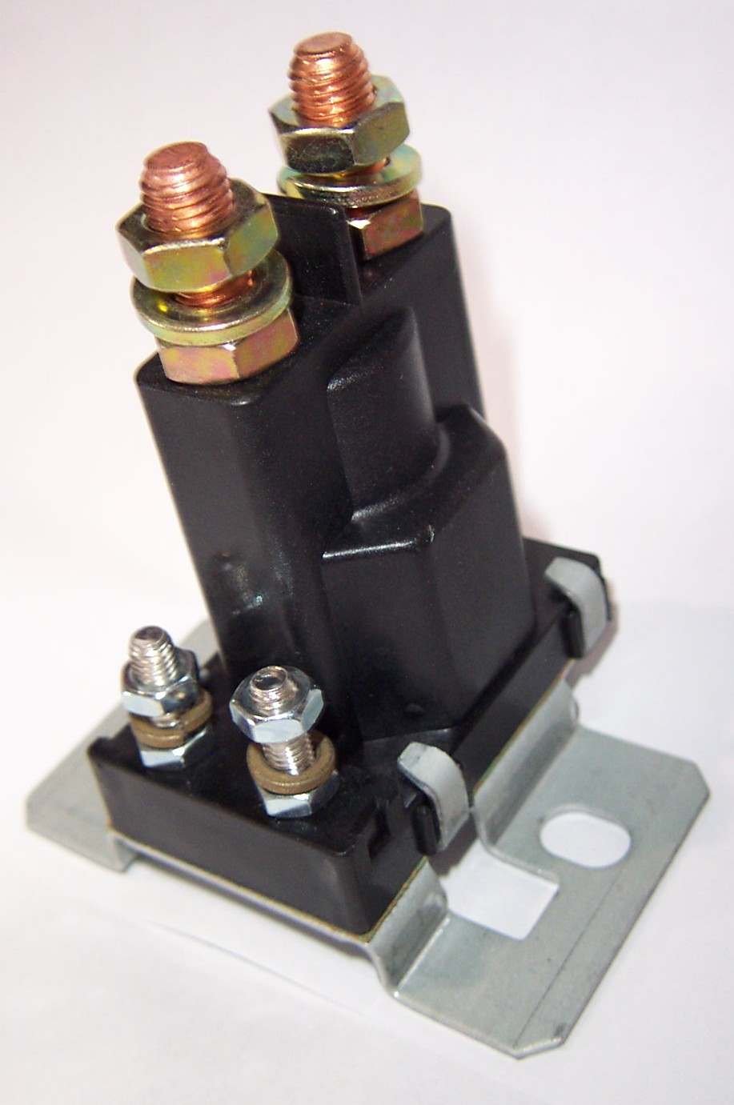
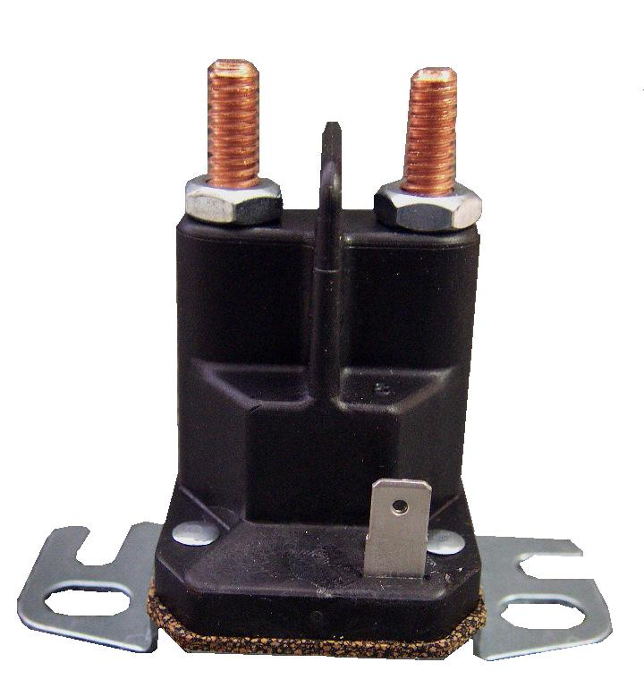

PHY157-130

Switch – Oil Pressure
Hydramaster: Boxxer 427,
Maxx 450D & Maxx 470D

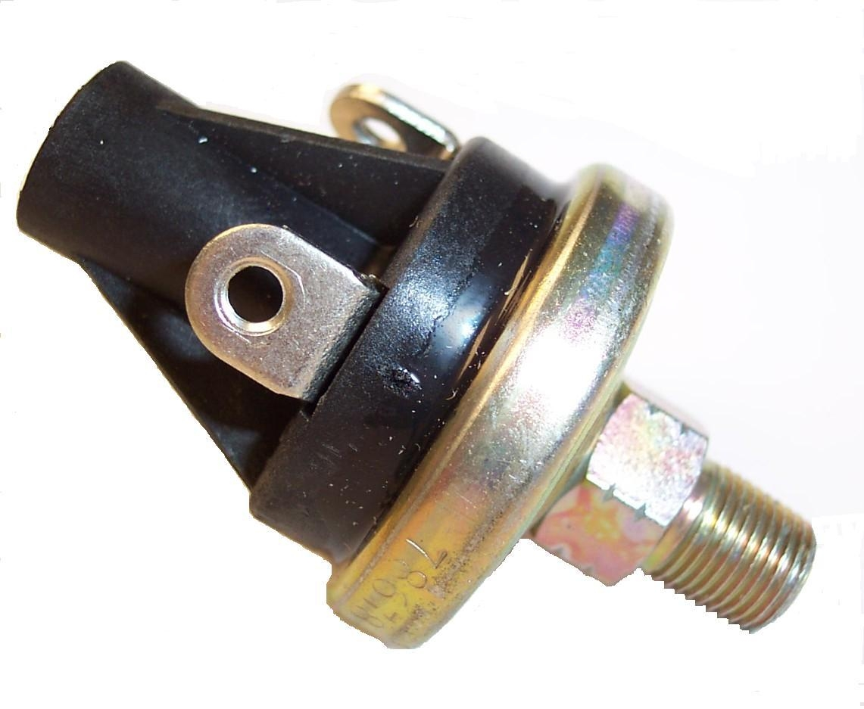
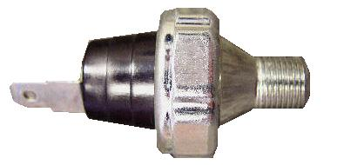
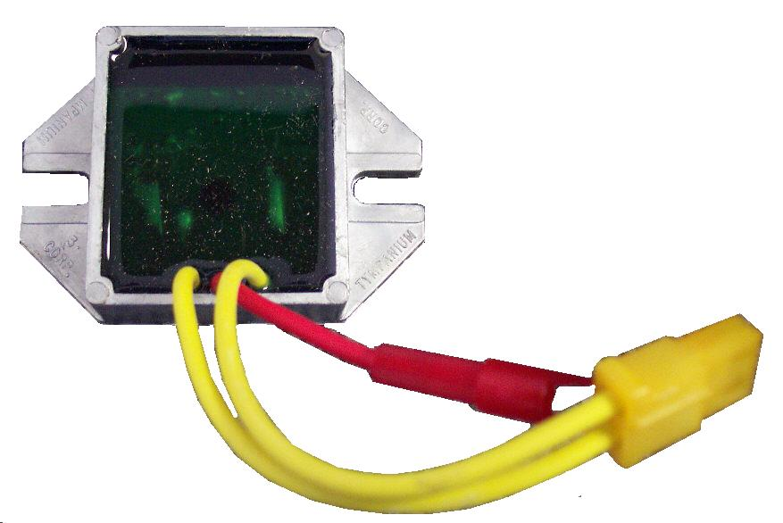

PFR691573

Voltage Regulator- 20AMP

Briggs & Stratton
Hydramaster: Boxxer 318,
Boxxer 421 & Boxxer 427

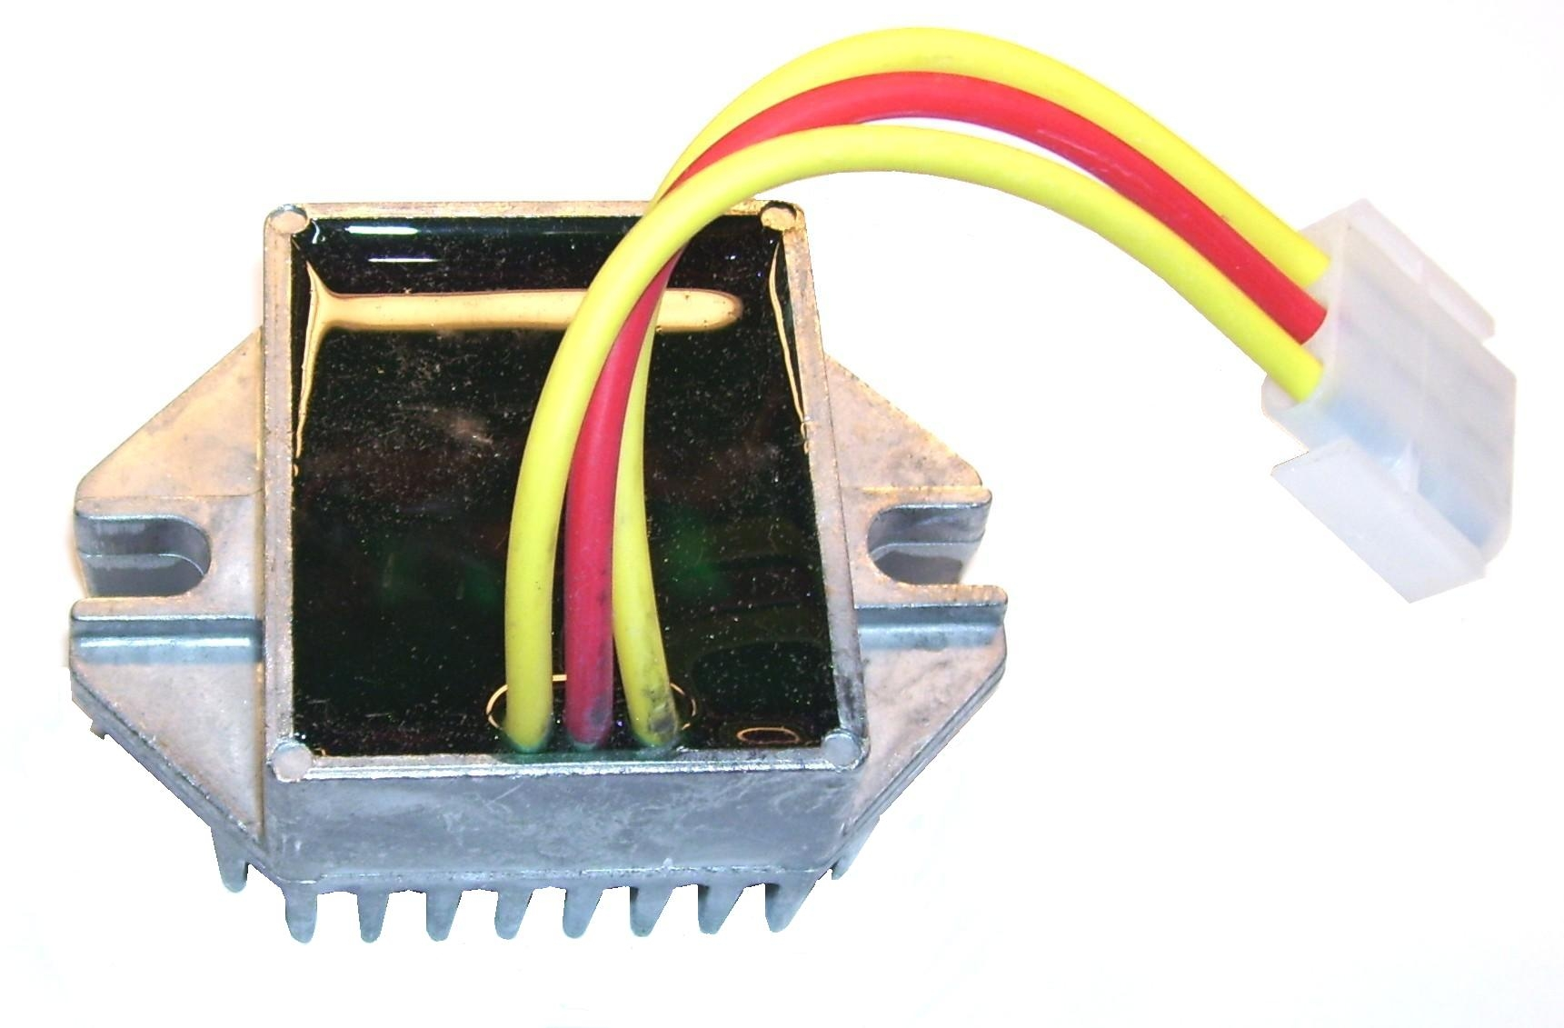
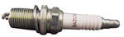
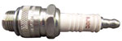

PFR399169

Starter Motor

Briggs & Stratton
Briggs & Stratton Part # 499521
Most Vanguard Engines

PFR-394808

Starter Motor

Briggs & Stratton - I/C Engine
Prochem: 100A
Hydramaster: Bobcat

Bridgepoint Parts Catalog

Section XXVII: Briggs & Stratton Engine Parts Page 3

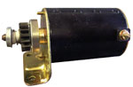

PHY072-011

Ignition Trigger

Daihatsu / Briggs & Stratton
Hydramaster: Maxx450D & 470D

PFR-280104

Gear – Starter

Briggs & Stratton
Most Vanguard Engines

PHY072-012

Ignition Coil

Daihatsu / Briggs & Stratton
Hydramaster: Maxx450D & 470D

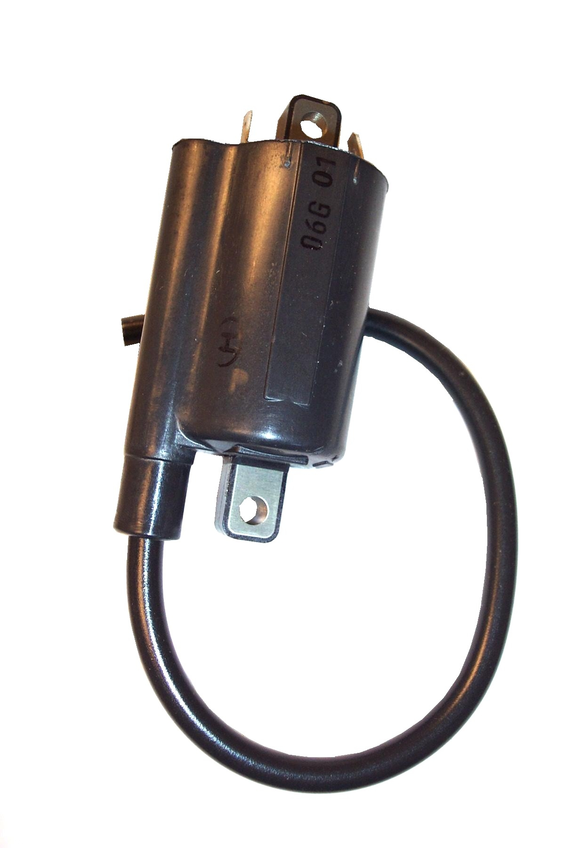
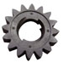

PFR-490467

Kit Spring – Starter

Briggs & Stratton

Most Vanguard Engines

PFR492341

Armature Magneto

Ignition Coil

Briggs & Stratton

Prochem: Trailblazer, Blazer, Blazer Plus, Blazer XL Cub, Cub XL, Power Vac & Oil Fired TM.
Bridgepoint: System IV, Saber, Saber 2000 & Dagger
Hydramaster: Boxxer 421, Crossfire 3.7, Profire 3.7, Spitfire 3.2, Spitfire 4.0, Hydracat 3.5 & Aquacat 3.5 & 3.9

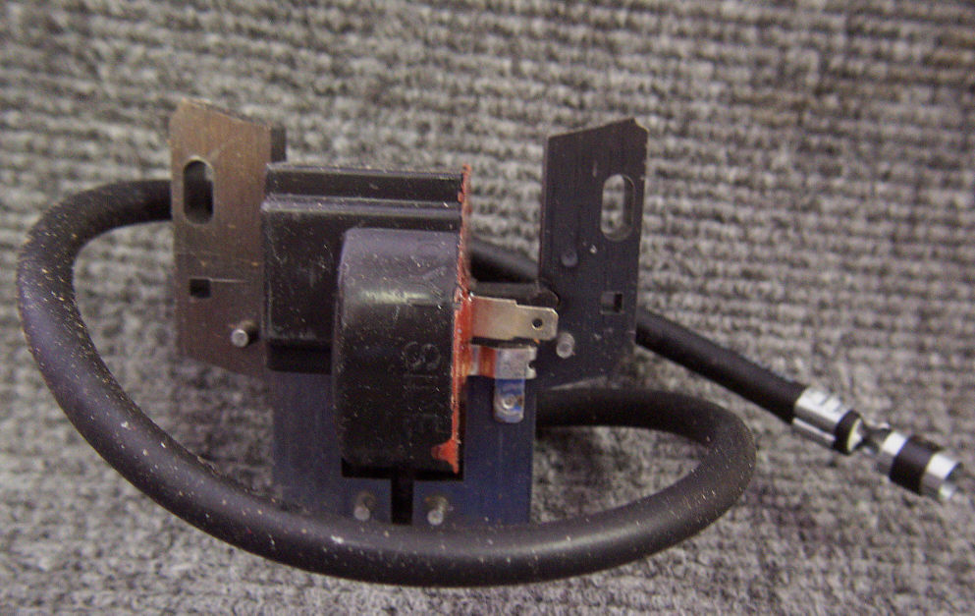

PFR495878

Drive Assembly – Starter

Briggs & Stratton
Older Vanguard Engines
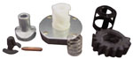

PFR692319

Ground Harness – Diode Wire

Ignition Coils

Briggs & Stratton

Prochem: Trailblazer, Blazer, Blazer Plus, Blazer XL, Cub, Cub XL, Power Vac & Oil Fired TM.
Bridgepoint: System IV, Saber, Saber 2000 & Dagger
Hydramaster: Boxxer 421, Crossfire 3.7, Profire 3.7, Spitfire 3.2, Spitfire 4.0, Hydracat 3.5 & Aquacat 3.5 & 3.9

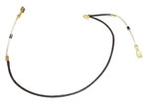

PFR696541

Drive Assembly – Starter

Briggs & Stratton
Newer Vanguard Engines

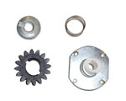

PFR691613

Gasket – Exhaust

Prochem: Trailblazer, Blazer, Blazer Plus, Blazer XL, Cub, Cub XL, Power Vac & Oil Fired TM.
Bridgepoint: System IV, Saber, Saber 2000 & Dagger
Hydramaster: Boxxer 421, Crossfire 3.7, Profire 3.7, Spitfire 3.2, Spitfire 4.0, Hydracat 3.5 & Aquacat 3.5 & 3.9

